# Questions

# Introduction to DevOPS

## **What is DevOps?**

DevOps is shorten for Development-Operations.

DevOps is a set of practices that merge tow concepts software development and operations, It aims to shorten the systems development life cycle and provide continuous delivery with high software quality.

## **What is the features that DevOps pushed to the market?**

• Accelerating time to market

• Adapting to the market and competition

• Maintaining system stability and reliability

• Improving the mean time to recovery

## **The number tells the story, describe the numbers that puppet collected for the high performance of DevOps?**

• 200 X more frequent deploys

• 24 X faster recovery times

• 3 X Lower change failure rates

## **At the planning phase of DevOps, describe how it can be agile-driven?**

it’s agile-driven in planning it shares the agile practices of Creating backlogs, tracking bugs, managing agile software development with Scrum, using Kanban boards and visualizing progress with dashboards are some of the ways DevOps teams plan with agility and visibility.

## **Mention Briefly how can you practice DevOps in Development phase?**

Working for this phase include everything about developing, testing, writing, reviewing and the integration of code between teams, it’s relative more about using git and other VCSs to fork, merge, commit, pull, push, for code and project components.

## **This phase is like to deliver orders to customers in their homes, How can that?**

the deliver phase is about sending the tested code as running app in production, and it ready to consume from users. Deploy to production environment means that app is stable enough and reliable to consume from customers.

## **What is the mission of Operate phase ?**

To make the production more stable, resilience. The Operate phase work for maintaining, monitoring, troubleshooting application in production environment. This phase aims to zero downtime while reinforcing security and governance.

## **The DevOps is not a man job, describe.**

the environment is shared, the team is align so take the ownership and become involved in additional lifecycle phases – not just the ones central to their roles, for example the developers become accountable in all phases not only the plan and develop but also the deploy and operate because the performance and stability is related to the code and the entire production environment.

## **What is the Configuration Management?**

The CM concept is working to find a stable way and tools to manage resources state, including servers, virtual machines and databases, using Configuration Management help the teams to roll out the changes in the environment once it happened.

## **10 – What is Continuous Monitoring?**

Continuous Monitoring means to have the real time visibility into the performance and health of the application stack or pool, that delivered to users from the infrastructure running to serve the application to the higher level software component.

## **11 – What is the shared point between Microservices and DevOps?**

DevOps practices reinforce the idea of breaking large problems into smaller pieces and tackling them one at a time as a team.

Microservices fits perfectly into the DevOps ideals of utilizing small teams to create functional changes to the enterprise’s services one step at a time. Microservices empower the implementation of small teams collaborating together in an environment of increased developer freedom.

## **12 – What is the difference between Virtualization and Containerization?**

**Virtualization**: is to have many virtual machines running on the same infrastructure using VM tool like VMware or KVM or Microsoft Hyper-V, every VM now has its Operating System and the libraries for each app to run it and the app itself.

**Containerization**: is to has a Containerization support app like docker or AWS Fargate or others, to run its software then it can cluster all developer apps and libraries without using any additional overheads to install so the deployment can be automated easily, fast shippable, and more.

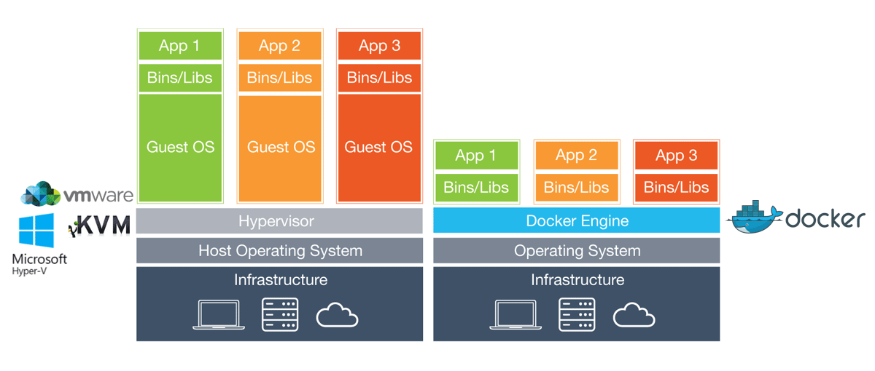

## **13 – How to Practice CI/CD on IOT?**

### **Continuous Integration for IOT**

CI ensures that the IoT applications that are a part of DevOps, and perhaps some that are not, are all considered a holistic application or system. These component parts are dependent upon one another, even components that are not under the direct control, such as sensors embedded in machines (e.g., a jet engine). This is a bit of a leap from traditional approaches to DevOps, where all components are under direct control.

### **Continuous Deployment for IOT**

CD is the most important component of DevOps and IoT. This is due to the fact that the application needs to live on a platform, say a IaaS cloud provider, as well as work and play with remote devices. This complicates the processes of deployment, in that there could be updates to the application that reside on a centralized cloud platform, and perhaps even firmware updates that reside on a remote sensor or device.

## **14- List some applications working as DevOps environment?**

* Azure DevOps
* GitHub
* GitLab
* Gera Bit Bucket
* Beanstalck

# **15 – List the advantages of shortening life cycle of SDLC?**

* these cycles make it easier to risk management and planning.
* Allows organizations to adapt and react to evolving customer needs and competitive pressure.

# **16– List the DevOps Practices?**

* Infrastructure as Code
* Version Controlling
* Agile Methodology
* CI/CD
* Continuous Monitoring
* Configuration Management

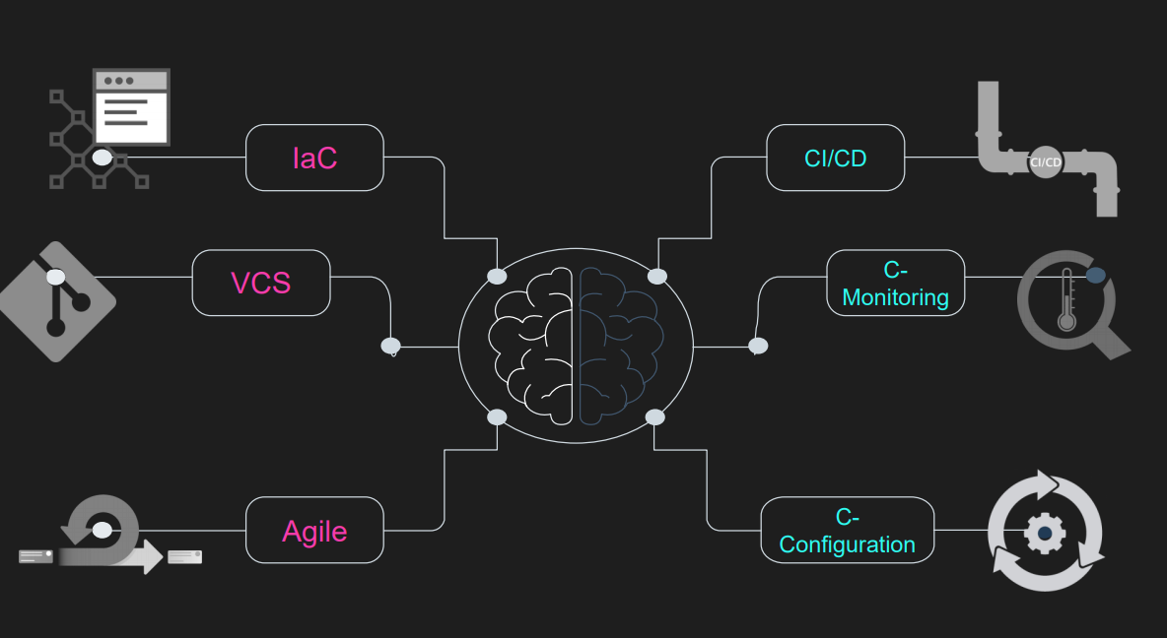

# **17 – What is the Version Control?**

Version control is a practice to manage the code into series of versions, as a practice, tracking revisions and change history to make code easy to review and recover. Like any system the user consume, it have many version of release and each number has its own features.

# **18 – What is Agile?**

Agile is a modern approach for software development that emphasizes team collaboration, customer and user continuous feedback, and high adaptability to change through short release cycles. The feedback from users is the main change director adjusted from the (need and want) of business today engines.

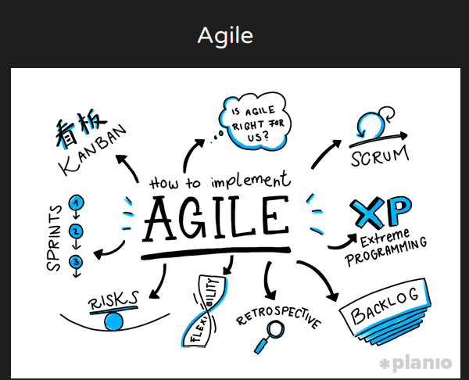

# **19 – List some of agile frameworks ?**

* SCRUM
* Kanban
* XP (Extreme Programming)
* FDDI
* Manifesto

# **20 – What is the mean of Infrastructure as Code?**

IaC defines system resources and topologies in a descriptive manner that allows the team to manage these resources as they code.

That mean to write just little files to manage the infrastructure within your project.

Ex: docker Compose files and Kubernetes.

# DevOps and Data Science

1. **What is Data science?**
2. Data science is a multi-disciplinary field that uses (scientific methods, processes, algorithms and systems) to extract knowledge and insights from many structural and unstructured data which are typically large.
3. A concept to unify statistics, data analysis, machine learning and their related methods in order to understand and analyze actual phenomena with data.
4. **What is the Impact of Data Science?**
   1. Big data is very quickly becoming a vital tool for businesses and companies of all sizes.
   2. Data-driven businesses are worth $1.2 trillion collectively in 2020, an increase from $333 billion in the year 2015.
5. **What are the skills data science should know?**
   1. Mathematics
   2. Software Engineering
   3. Machine Learning
6. **What are Data Science Steps?**
   1. Data Gathering
   2. Data Preparation
   3. Data Exploration
   4. Building Model
7. **What is the difference between data science and business intelligence?**
   1. Data science in term of future
   2. BI interim of past and present
8. **What are 3V’s?**
   1. Volume
   2. Velocity
   3. Variety
9. **What is the role of machine learning in data science?**
   1. is about how systems learn from data.
   2. Use to train on data to make decisions.
10. **What are the two ways systems learn from?**
    1. Supervised
    2. Unsupervised
11. **List three data science goals?**
    1. Prediction (predict a value based on inputs)
    2. Classification (e.g., spam or not spam)
    3. Recommendations (e.g., Amazon, Wuzzuf and Netflix recommendations)
12. **What is the most famous container-orchestration system in computer application deployment?**
    1. Kubernates
13. **Which is the most important language for Data Science?**
    1. R
14. **What is meant by raw data?**
    1. Raw data is the original source of data.
15. **What is the relation between Data Science and Statistics?**
    1. Many statisticians have argued that data science is not a new field, but rather another name for statistics.
    2. Others argued that data science is distinct from statistics because it focus on problems and techniques unique to original data.
    3. Finally it is described as an applied field of traditional statistics.
16. **What is meant by supervised Learning?**
    1. A system produces decisions (outputs) based on input data.
    2. The system is given a historical data sample of inputs and known outputs, and it “learns” the relationship between the two using machine learning techniques.
17. **What is meant by unsupervised learning?**
    1. is a process of reorganizing and enhancing the inputs in order to place structure on unlabeled data.

IOT

# Introduction to IOT

1-What is the internet of things(iot)?

Iot is the integration of objects with the world of the internet, by attaching hardware (sensors) or/and software to make these objects smart and so be able to communicate with each other and participate effectively in all aspects of daily life.

2-What are the iot advantages and disadvantages?

IOT Advantages

Dynamic control of industry & daily life -

Improve the resource utilization ratio-

-Integrating human society & physical systems

Flexible configuration -

Universal transport & internetworking -

Acts as technologies integrator-

IOT Disadvantages

Safety-

Security-

-Compatibility

Complexity

3-How do you secure an IOT solution?

-Create more effective and secure password policies.

-Use IOT PKI Security Methods.

-Authenticate the IOT Devices.

-Secure the IOT Network.

-Use encrypted protocols to secure communications.

4-Why do we need IOT security?

Encryption can help prevent unauthorized access

to data and devices. This helps maintain data integrity and prevent data sniffing by hackers so you must use Authentication.

5-What are the IOT Challenges?

-Sensing a complex environment

Innovative ways to sense and deliver information from the physical world to the cloud

-Connectivity

Variety of wired and wireless connectivity standards are required to enable different application needs

-IOT is complex

IOT application development needs to be easy for all developers, not just to exports

- Cloud is important

IOT applications require end-to-end solutions including cloud services

6-What are the IOT Characteristics?

Ambient intelligence-

Event Driven-

Flexible Structure-

Complex access technology-

Semantic Sharing-

7-What is meant by Complex access technology?

means that there's several kinds of media such as vehicle stone that they need different access technologies.

8-What is different between Flexible Structure and Semantic Sharing in iot?

Flexible Structure: means that hundreds and thousands of nodes will be disable and will be set to run

Semantic Sharing: is the machine can rend and send by themselves. No need to tell human beings

9-What are the Problems and security challenges in iot security?

-Need new devices for endpoint security, new firewalls, embedded OS, new software & etc.

-It is not possible to support AV (anti-virus) on every device.

-Need new transport protocols for making network security difficult.

-Applying security analysis leads to much more network traffic.

-Bad news for large enterprises as network security is already complex and complicated for most of enterprises.

10-What are the IOT Applications?

-Education -Food

-Management -Retail

-Health Care -Logistics

11-What is Ambient intelligence in iot?

-AMI refers to electronic environments that are sensitive and responsive to the presence of people

-The independent & intelligent entities will act in full interoperability & will be able to auto-organize themselves depending on The context, circumstances or environment

12-What is different between Flexible Structure and Event Driven in iot?

Flexible Structure: means that hundreds and thousands of nodes will be disable and will be set to run

Event Driven: is to design the scheme depending on the need

13-Mention the basic difference between IoT and sensor businesses?

A sensor business does not need an active internet connection to work. Internet of Things requires a control side to work.

14-What is IoT Testing?

IoT testing is a type of testing to check IoT devices. Today there is an increasing need to deliver better and faster services. There is a huge demand to access, create, use, and share data from any device. The thrust is to provide greater insight and control over various interconnected IoT devices. Hence, the IoT testing framework is important.

15-What are the types of IoT?

There are two types of IoT:

Internet of Things: It creates a business that uses a gadgets to perform a task.

Industrial Internet of Things: It creates business in the industry like agriculture.

# IOT Technologies and Protocols

## What is Bluetooth?

The new Bluetooth or Bluetooth Smart is a significant protocol for IoT applications.

it offers a similar range to Bluetooth it has been designed to offer significantly reduced power consumption.

It is expected to be key for wearable products in particular, connecting to the IoT via a smartphone in many cases.

## What is Zigbee?

ZigBee is similar to Bluetooth used in industrial settings.

It has some significant advantages in complex systems offering low-power operation, high security, robustness and high and is well positioned to take advantage of wireless control and sensor networks in iot applications .

## What is the main feature added to last version of Zigbee?

The latest version of ZigBee which is essentially the unification of the various ZigBee wireless standards into a single standard.

## What is the features of WIFI?

WiFi eliminates the need for an access point.

It allows P2P (peer-to-peer) connections with the speed of WiFi, but with lower latency.

WiFi-Direct eliminates an element of a network that often bogs it down, and it does not compromise on speed or throughput.

## What is NFC?

NFC (near-field communication) provide simple, low energy, and versatile options for identity and access tokens, connection bootstrapping , payments, and specifically for smartphones.

## Why we use cellular network than WIFI?

Any IoT application that requires operation over longer distances can take advantage of GSM/3G/4G cellular communication capabilities.

## What is the disadvantage of cellular network?

While cellular is clearly capable of sending high quantities of data, especially for 4G, the cost and also power consumption will be too high for many applications.

## What is Lora WAN?

Network that can target wide-area network (WAN) applications.

The Lora WAN design to provide low-power WANs with features specifically needed to support low-cost mobile secure communication in IOT , smart city, and industrial applications. Specifically meets requirements for low-power consumption and supports large networks with millions and millions of devices, data rates range from 0.3 kbps to 50 kbps.

Cloud

# Cloud IOT

**Q1: Comparison between IOT and Cloud Computing**

|  |  |  |
| --- | --- | --- |
| **Items** | **IoT** | **Cloud Computing** |
| Characteristics | IoT is pervasive (things are everywhere).  These are real world objects | Cloud is ubiquitous (resources are available  from everywhere).These are virtual resources |
| Processing  capabilities | Limited computational capabilities. | Virtually unlimited computational capabilities. |
| Storage  capabilities | Limited storage or no storage capabilities. | Unlimited storage capabilities. |
| Connectivity | It uses the Internet as a point of convergence | It uses the Internet for service delivery. |
| Big data | It is a source of big data | It is a means by which to manage big data. |

**Q2: The Architecture of Cloud-Based IOT consist from three layer .mention this layers**

**1-**Sensing layer **2-** Network layer **3-**Application layer

**Q3: what are the Cloud-Based IOT Applications?**

1-Healthcare 2-Smart Cities 3-Automotive and Smart Mobility 4-Smart energy and smart grid 5-Smart logistics 6-Smart Homes 7-Environmental Monitoring 8-Video monitoring

**Q4: what are the Challenges Facing Cloud -Based IOT Integration? Explain big data briefly**

**1-Security and privacy 2-Heterogeneity 3-Big data 4-Performance**

**5-Legal aspects**  **6-Monitoring 7- Large scale**

**Big data**

the IoT will be one of the core sources of big data, and that the Cloud can facilitate the storage of this data for a long period of time. manage massive amounts of data is still a big issue .but also because of security and privacy issues.

**Q5: What is the role of Cloud Computing in IoT?**

• Devices of IoT technology produce a massive amount of data.

• It is very much difficult to handle those data with traditional technology. But the use of cloud computing technology provides appropriate solutions.

• Cloud server increases speed, the efficiency of IoT applications, and at the same time, ensures the availability of resources to the user.

• Cloud computing provides necessary tools and services to create IoT applications. Cloud helps in achieving efficiency, accuracy, speed in implementing IoT applications.

**Q6: what is Internet of Things**

Internet of Things (IoT) refers to a system of connected physical objects via the internet. the data collects and transfers over the internet without any manual intervention with the help of embedded technology. It helps them to interact with the external environment or internal states to take the decisions.

**Q7: what is Cloud Computing**

Cloud computing is a model for enabling convenient, on-demand network access to a shared pool of configurable computing resources (e.g., networks, servers, storage, applications, and services) that can be rapidly provisioned and released with minimal management effort or service provider interaction.

**Q8: healthcare is one of the Cloud-Based IOT Applications explaining briefly**

it can signicantly improve healthcare services , CloudIoT employed for simplify healthcare processes and allows to enhance the quality of the medical services by enabling the cooperation among the different entities such as: collecting patients' vital data via a network of sensors connected to medical devices, delivering the data to a medical center's Cloud for storage and processing.

**Q9:** **Security and privacy one of CloudIOT challenges .explain briefly**

The problem how to provide appropriate authorization rules and policies while ensuring that only authorized users have access to the sensitive data, to preserving users’ privacy, and particularly when data integrity must be guaranteed. public key cryptography cannot be applied to all layers because of the processing power constraints imposed by IoT objects.

**Q10: What are the benefits of using IOT with Cloud Computing?**

• IoT and cloud computing has a complementary relationship. While IoT generates large amounts of data, many cloud providers allow data transfer via the internet, that means facilitates a way to navigate the data.

• Cloud computing helps to collaborate in IoT development. Using Cloud platform, IoT developers can store the data remotely and access easily.

• Cloud computing helps to advance analytics and monitoring of IoT devices

**Q11:** **how is the Cloud Computing optimize the Internet of Things**

1- Optimize Deployment of IoT Tech in Business

2-optimize Security

3-optimize Data Reporting & Validation

**Q12: Heterogeneity one of CloudIOT challenges .explain briefly**

Cloud platforms suffer from heterogeneity. The heterogeneity challenge can be exacerbated when end-users adopt multi-Cloud approaches, and thus services will depend on multiple providers to improve application performance

**Q13- explain briefly the work of Cloud-Based IOT layers**

1-The Sensing (perception) layer is used to identify objects and collection data from the environment.

2- The network layer is to transfer the collection data to the Internet/Cloud.

3- The application layer provides the interface to different services.

**Q14: What meant the Legal aspects and large scale in Challenges Facing Cloud -Based IOT Integration?**

**Legal aspects**

CloudIoT service based on user-provided data. service providers must adapt to various international regulations. users should give donations in order to contribute to data collection.

**Large scale**

The Cloud-based IoT paradigm makes it possible to design new applications that aim to integrate and analyse data coming from the real world into IoT objects.

**Q15: what is the Cloud-based Internet of Things different than conventional Internet of Things?**

The ability to develop deploys, run, and manage Things applications online by

the Cloud.